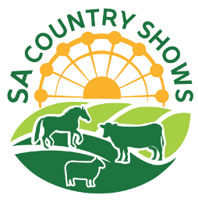
2026 SOUTH AUSTRALIAN YOUNG RURAL AMBASSADOR AWARD
ENTRY FORM
Please complete this entry form and lodge it with the Secretary or Rural Ambassador Award Convenor
of the Show Society that you wish to represent.

Representing: __________________________________________________ ____ (Show Society)
From the: (Show Association)
Given Name: Surname:
Preferred Name: Date of Birth: / /
Postal Address:
Town: Post Code:
Phone: Mobile:
Email:
I have read a copy of the 2026 Young Rural Ambassador Award entry criteria and agree to abide by the rules and regulations stated, including:
- I agree to represent my local show (if selected) at the association, and state final;
- I have not entered the Young Rural Ambassador Award at any other association this show season;
- I agree to provide a copy of my CV and an introductory letter for show society, association, and state final judging by the required dates;
- I am aged between 16 years and under 20 years as of the 1st of May 2026 (i.e. born between the 2nd of May 2006 and the 1st of May 2010 inclusively);
- If selected as a winner of my association, I will attend the state final held at the Adelaide Showground, in conjunction with the SA Country Shows Symposium on the 17th of July 2026
- As a state finalist I consent for my name and contact details to be made available on the SA Country Shows website for show societies should they wish to contact me;
- I agree to my photo being taken, and used as detailed in the entry criteria;
- If selected as the state winner of the Young Rural Ambassador Award, I agree to attend the Royal Adelaide Show from 12:30pm on Friday the 4th of September (pre-show) to 6:00pm on Sunday the 6th of September 2026 (dates to be confirmed).

Signed: Date: / /

