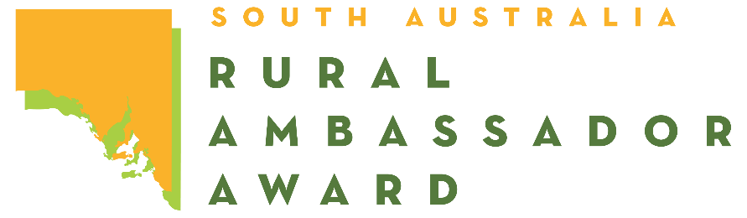
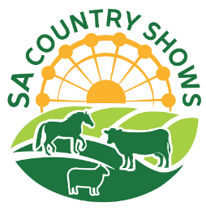
2026 SOUTH AUSTRALIAN RURAL AMBASSADOR AWARD
ENTRY FORM
Please complete this entry form and lodge it with the Secretary or Rural Ambassador Award Convenor
of the Show Society that you wish to represent.

Representing: (Show Society)
From the: (Show Association)
Given Name: Surname:
Preferred Name: Date of Birth: / /
Postal Address:
Town: Post Code:
Phone: Mobile:
Email:

I have read a copy of the 2026 Rural Ambassador Award entry criteria and agree to abide by the rules and regulations stated, including:

- I agree to represent my local show (if selected) at the association, and state final;
- I have not entered the Rural Ambassador Award at any other association this show season;
- I agree to provide a copy of my CV and an introductory letter for show society, association, and state final judging by the required dates;
- I am aged between 20 years and under 30 years as of the 1st of May 2026 (i.e. born between the 2nd of May 1996 and the 1st of May 2006 inclusively);
- As a state finalist I consent for my name and contact details to be made available on the SA Country Shows website for show societies should they wish to contact me;
- I agree to my photo being taken, and used as detailed in the entry criteria;
- If selected as the winner of my association, I agree to attend the state final conducted during the 2026 Royal Adelaide Show from 12:30pm on Friday the 4th of September (pre-show) to 10:00pm on Tuesday the 8th of September 2026 (dates to be confirmed).
- If selected as state winner of the Rural Ambassador Award, to represent South Australia in the Agricultural Shows Australia National Finals in 2027, date and location to be advised.

Signed: Date: / /

