**ENTRY FORM**

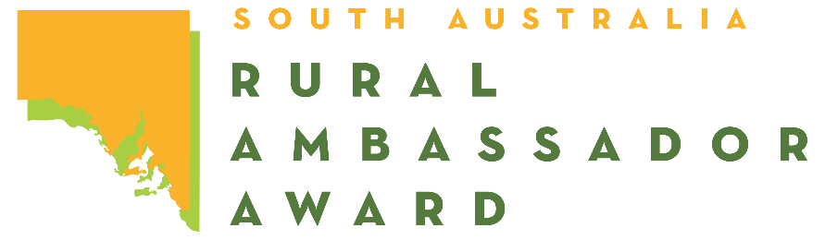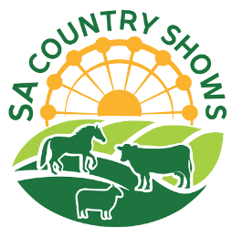

*Please complete this entry form and lodge it with the Secretary or Rural Ambassador Award Convenor   
of the Country Show Society that you wish to represent.*

Representing: Show Society  
From the: Association

Given Name: Surname:   
Preferred Name: Date of Birth: / /

Postal Address:

Town: Post Code:

Mobile: Facebook name:

Email:

I have read a copy of the Rural Ambassador Award entry criteria and agree to abide by the rules and regulations stated, including:

* I agree to represent my local show (if selected) at the association, and state final;
* I have not entered the Rural Ambassador Award at any other association this show season;
* I agree to provide a copy of my CV and an introductory letter for show society, association, and state final judging by the required dates;
* I am aged between 20 years and under 30 years as at the 1st of May 2026 (i.e., born between the 2nd of May 1996 and the 1st of May 2006 inclusively);
* If selected as winner of my association, I agree to attend the state final conducted during the 2026 Royal Adelaide Show from 9:00am on Friday the 4th September to 10:00pm on Tuesday the 8th of September 2026 (dates to be confirmed).
* As a state finalist I consent for my name and contact details to be made available on the SA Country Shows website for show societies should they wish to contact me.
* I agree to be contacted via Facebook and added to a social media chat group with other ambassadors.
* I agree to the photography and media requirements listed in the entry criteria. being taken and used as detailed in the entry criteria.
* If selected as the state winner of the Rural Ambassador Award, I agree to represent South Australia in the Agricultural Shows Australia National Finals in August 2027 in Brisbane (details to be advised).
* By participating in the Rural Ambassador Award, I agree to uphold the Code of Conduct listed in the entry criteria. Failure to adhere to this Code of Conduct may result in disqualification or loss of prizes.

Signed: Date: / /