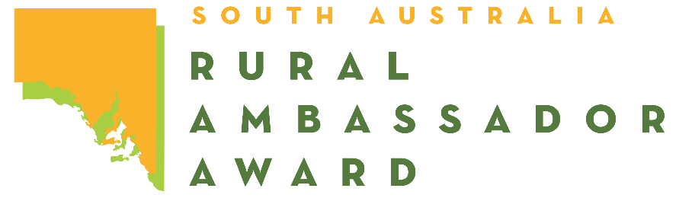
2023 SOUTH AUSTRALIAN RURAL AMBASSADOR AWARD
ENTRY FORM

Please complete this entry form and lodge it with the Secretary or Rural Ambassador Award Convenor
of the Country Show Society that you wish to represent.

Representing Show Society
From the: Association

Given Name:
Preferred Name:
Surname:
Date of Birth: / /
Postal Address:
Town:
Phone:
Post Code:
Mobile:

Email:
I have read a copy of the 2023 Rural Ambassador Award entry criteria and agree to abide by the rules and regulations stated, including:

- I agree to represent my local show (if selected) at the association, and state final;
- I have not entered the Rural Ambassador Award at any other association this show season;
- I agree to provide a copy of my CV and an introductory letter for show society, association, and state final judging by the required dates;
- I am aged between 20 years and 30 years as of the 1st of May 2023 (i.e., born between the 2nd of May 1993 and the 1st of May 2003 inclusively);
- As a state finalist I consent for my name and contact details to be made available on the SA Country Shows website for show societies should they wish to contact me;
- I agree to my photo being taken, and used as detailed in the entry criteria;
- If selected as winner of my association, I agree to attend the state final conducted during the 2023 Royal Adelaide Show from 1:30pm on Friday the 1st (pre-show) to 10:00pm on Tuesday the 5th of September 2023;
- If selected as state winner of the Rural Ambassador Award, I agree to represent South Australia in the Agricultural Shows Australia National Finals in 2024, date and location to be advised.

Signed:
Date: / /

