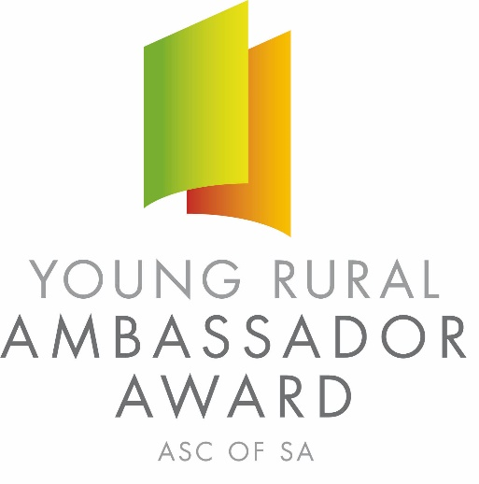
2021 SOUTH AUSTRALIAN YOUNG RURAL AMBASSADOR AWARD

Conducted by SA Country Shows
ENTRY FORM
Please complete this entry form and lodge it with the Secretary of the Country Show Society you wish to represent.

Representing: Show Society
From the: Association
Given Name: _________________________________ Surname:
Preferred Name: _______________________________ Date of Birth:
Postal Address:
________________________________________________ Post Code:
Phone: Fax: Mobile:
Email:
I agree to abide by the entry criteria for the Young Rural Ambassador Award, including:

- I agree to represent my local show (if selected) at the association final and have not entered the Young Rural Ambassador Award at any other association this show season;
- I agree to provide a copy of my CV and an introductory cover letter for local, association and state final judging by the required date;
- Be aged 16 years and under 20 years on the 1st May 2021 (E.g. born between 2nd May 2001 and 1st May 2005 inclusive);
- If selected as winner of my association, attend the state final on Friday 9th July 2021 at the Adelaide Showground (date to be confirmed);
- As a state finalist I consent for my name and contact details to be made available on the SA Country Shows website for show societies should they wish to contact me;
- If selected as state winner of the Young Rural Ambassador Award, attend the 2021 Royal Adelaide Show from 4:30 pm Friday 3rd September to 6:00 pm Sunday 5th September 2021.

Signed: Date:

