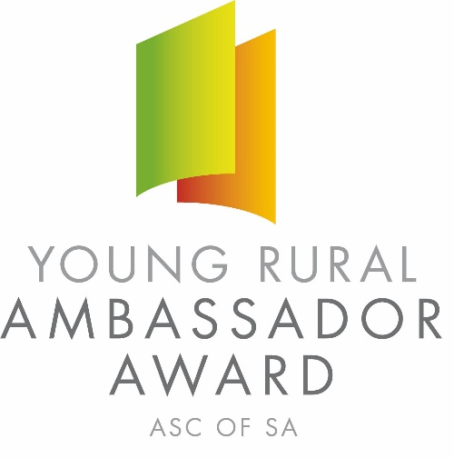
2021 SOUTH AUSTRALIAN YOUNG RURAL AMBASSADOR AWARD
Conducted by SA COUNTRY SHOWS

REGULATIONS AND ENTRY CRITERIA

The Young Rural Ambassador Award is conducted by SA Country Shows who will be duly responsible for selecting the state winner.

All entrants who enter the award must provide an undertaking that they will abide by the regulations and entry conditions as set out and to abide by the decisions of SA Country Shows.

The regulations apply to all three levels of this award at local country show society, association and state level.

The award will be run by qualification through country shows to association finals with a state final being held in July 2021 prior to the 2021 Royal Adelaide Show.

AIMS:
- To highlight the importance of youth in rural South Australia and in particular the agricultural show movement.
- To identify and encourage enthusiastic, skilful, industrious and unselfish young people.
- To give young people a forum to express their views through education and experience and develop closer links with the primary industries in South Australia.

ENTRY REQUIREMENTS: Entrants must -
- Apply for and complete the entry form.
- Provide information indicating their reasons for applying for entry together with curriculum vitae, indicating work experience, community participation and agricultural show involvement.
- Be residents of South Australia.
- Be aged 16 years and under 20 years on the 1st May 2021 (E.g. born between 2nd May 2001 and 1st May 2005 inclusive).
- Be enthusiastic and knowledgeable about rural life and affairs, and agricultural shows.
- Be able to spend the required time at the local show, association level finals and the state final held at the Royal Adelaide Showground on Friday 9th July 2021 prior to the 2021 Royal Adelaide Show.
- As a state finalist consent for your name and contact details to be made available on the SA Country Shows website for show societies should they wish to contact you.
- State winner to be available to attend the 2021 Royal Adelaide Show between 4:30 pm Friday 3rd September and 6:00 pm Sunday 5th September 2021.

JUDGING CRITERIA:
- Entrants must wear smart casual clothing suitable for an autumn or spring show.
- Entrants to be judged in accordance with the following guidelines:
Country Show Involvement 15 points
Community Involvement 15 points
General and Rural Knowledge 20 points
Personal Presentation/Personality 20 points
Ambitions/Goals 10 points
Communication Skills 10 points
Dinner/Interview/General Interaction 10 points
TOTAL 100 points

YOUNG RURAL AMBASSADOR AWARD STRUCTURE
Country Show Society Level
All entrants must complete the award entry form. Show societies may only select one award winner each year, with other placegetters eligible to re-enter the following year. The participant selected at the country show society level represents that society at the association final. If the representative at show society level is unable to represent the society in the association final judging, then that society may select another participant to be their representative (E.g. runner up at a local level if there is one).

Association Level
Finalists at the association level must be able to attend both an interview with a judging panel and a lunch/afternoon tea/dinner function held on the same date at a time and venue stipulated by the association. If a finalist is unable to attend both then the show society will need to select another participant to be their representative (E.g. runner up).
The association secretary must forward the entry form of the association winner to the secretary of SA Country Shows immediately following the association final. A recommendation is for all association finals to be held during the autumn in the same year as the state final in July 2021. If the association winner is unable to attend the state final, then the runner up will be asked to take their place.

State Level
The winner selected at the association level represents that association in the state final to be conducted on Friday 9th July 2021 (date to be confirmed) at the Royal Adelaide Showground prior to the 2021 Royal Adelaide Show.
The state winner will get the opportunity to spend two days at the Royal Adelaide Show from the 3rd – 5th September 2021.
The winner of the state final is the Young Rural Ambassador Award winner for that year.

Eligibility to Re-enter
The winner of a previous state final is not eligible to enter the Young Rural Ambassador Award again. Previous state finalists are eligible to enter the award a maximum of twice, with a minimum gap of 2 years between their 1st and 2nd state final. After this period they are eligible to enter at country show level.

Judging Panel
One of the judges at all three of the levels (country show society, association and state) should be (if possible) a past Young Rural Ambassador state finalist, with show societies and associations encouraged to invite ambassadors from other areas to be judges. A list of previous Young Rural Ambassador state finalists’ contact details is available from the secretary of SA Country Shows.

Alterations to Regulations
Requests for alterations to or exemptions from these regulations are to be made in writing and forwarded to the association secretary and secretary of SA Country Shows by the 1st March 2021. SA Country Shows reserves the right to alter the rules and regulations of the award. Any alterations approved will be notified in writing to all show secretaries.

Awards/Prizes

Country show societies and associations are to be responsible for determining the prizes at their own levels.

State finalists of the South Australian Young Rural Ambassador Award will all receive participant prizes kindly donated by the award sponsors.

The major prize for the winner of the state final includes the opportunity to spend 2 days at the 2021 Royal Adelaide Show with the Rural Ambassador state finalists and a clothing package from RM Williams to wear during their time at the Royal Adelaide Show.

The state winner must advise of their availability to attend the Royal Adelaide Show within 30 days of the Young Rural Ambassador Award state final. The runner up will receive a RM Williams shirt and belt.

The Young Rural Ambassador Award is conducted by
SA Country Shows

and proudly sponsored by

Primary Industries & Regions SA
RA&HS Education Foundation
Stock Journal Publishers
RM Williams
The Showmen’s Guild of SA
Gallagher Insurance

2021 SOUTH AUSTRALIAN YOUNG RURAL AMBASSADOR AWARD

Outlined below are recommendations for the level of commitment that will be expected of Young Rural Ambassador Award entrants at country show society, association and state levels.

These are to be used as a guide only and it is up to the discretion of Young Rural Ambassador Award entrants, show societies and associations as to whether they are adhered to, but it will be encouraged.

The level of commitment which people can offer will depend on employment, family, sporting, study and other commitments so this will vary between individuals.

Country Show Society Level
- Entrants will attend their local show.
- Entrants offered an invitation to attend the official opening of the show.
- Entrants offered an invitation to attend the show’s official luncheon/afternoon tea etc.
- Winner of the award to accompany the official party during the show.
- Winner to be encouraged and supported in the writing of thank you letters to the show society and sponsors.
- Entrants offered a position on the show management committee or other sub committees.

Association Level
- Association winner invited to attend all the association shows.
- Association winner offered an invitation to attend the official opening of each show in the association.
- Association winner offered an invitation to attend each show’s official luncheon/afternoon tea etc and to accompany the official party at the show.
- Association winner encouraged to write thank you letters to their association and sponsors.
- Association winner offered a position as an association delegate and invited to the association AGM and other relevant functions.
- Country show winners invited to attend association AGM and other relevant functions.

State Level
- The state winner is encouraged to attend a country show from each association during their 12 months as the state winner.
- Associations are encouraged to invite the state winner to attend one of their shows.
- The state winner offered an honorary position on the Agricultural Societies Council of South Australia Inc Executive as an observer.
- All state finalists to be utilised as judges at local and association levels, with show societies and associations encouraged to invite state finalists from other associations.
- All state finalists are encouraged to write thank you letters to SA Country Shows and the Young Rural Ambassador Award sponsors.

