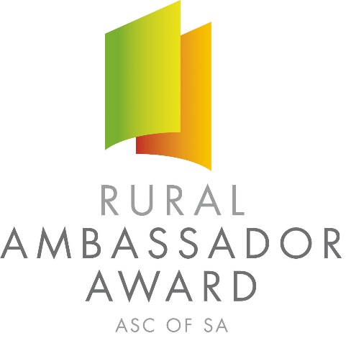
2021 SOUTH AUSTRALIAN RURAL AMBASSADOR AWARD

Conducted by SA Country Shows

ENTRY FORM
Please complete this entry form and lodge it with the Secretary of the Country Show Society you wish to represent.

Representing: Show Society
From the: Association
Given Name: _________________________________ Surname:
Preferred Name: _______________________________ Date of Birth:
Postal Address:
________________________________________________ Post Code:

Phone: Fax: Mobile:
Email:
I have read a copy of the Rural Ambassador Award entry criteria and agree to abide by the rules and regulations stated, including:

- I agree to represent my local show (if selected) at the association final;
- I have not entered the Rural Ambassador Award at any other association this show season;
- I agree to provide a copy of my CV and an introductory cover letter for local, association and state final judging by the required date;
- I am aged between 20 years and under 30 years as at the 1st May 2021 (E.g. born between 2nd May 1991 and 1st May 2001 inclusive);
- As a state finalist I consent for my name and contact details to be made available on the SA Country Shows website for show societies should they wish to contact me;
- If selected as winner of my association, I agree to attend the state final conducted during the 2021 Royal Adelaide Show from 4:30 pm Friday 3rd September to 10:00 pm on Tuesday 7th September 2021.

Signed: Date:

