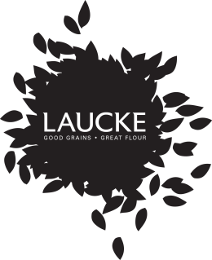
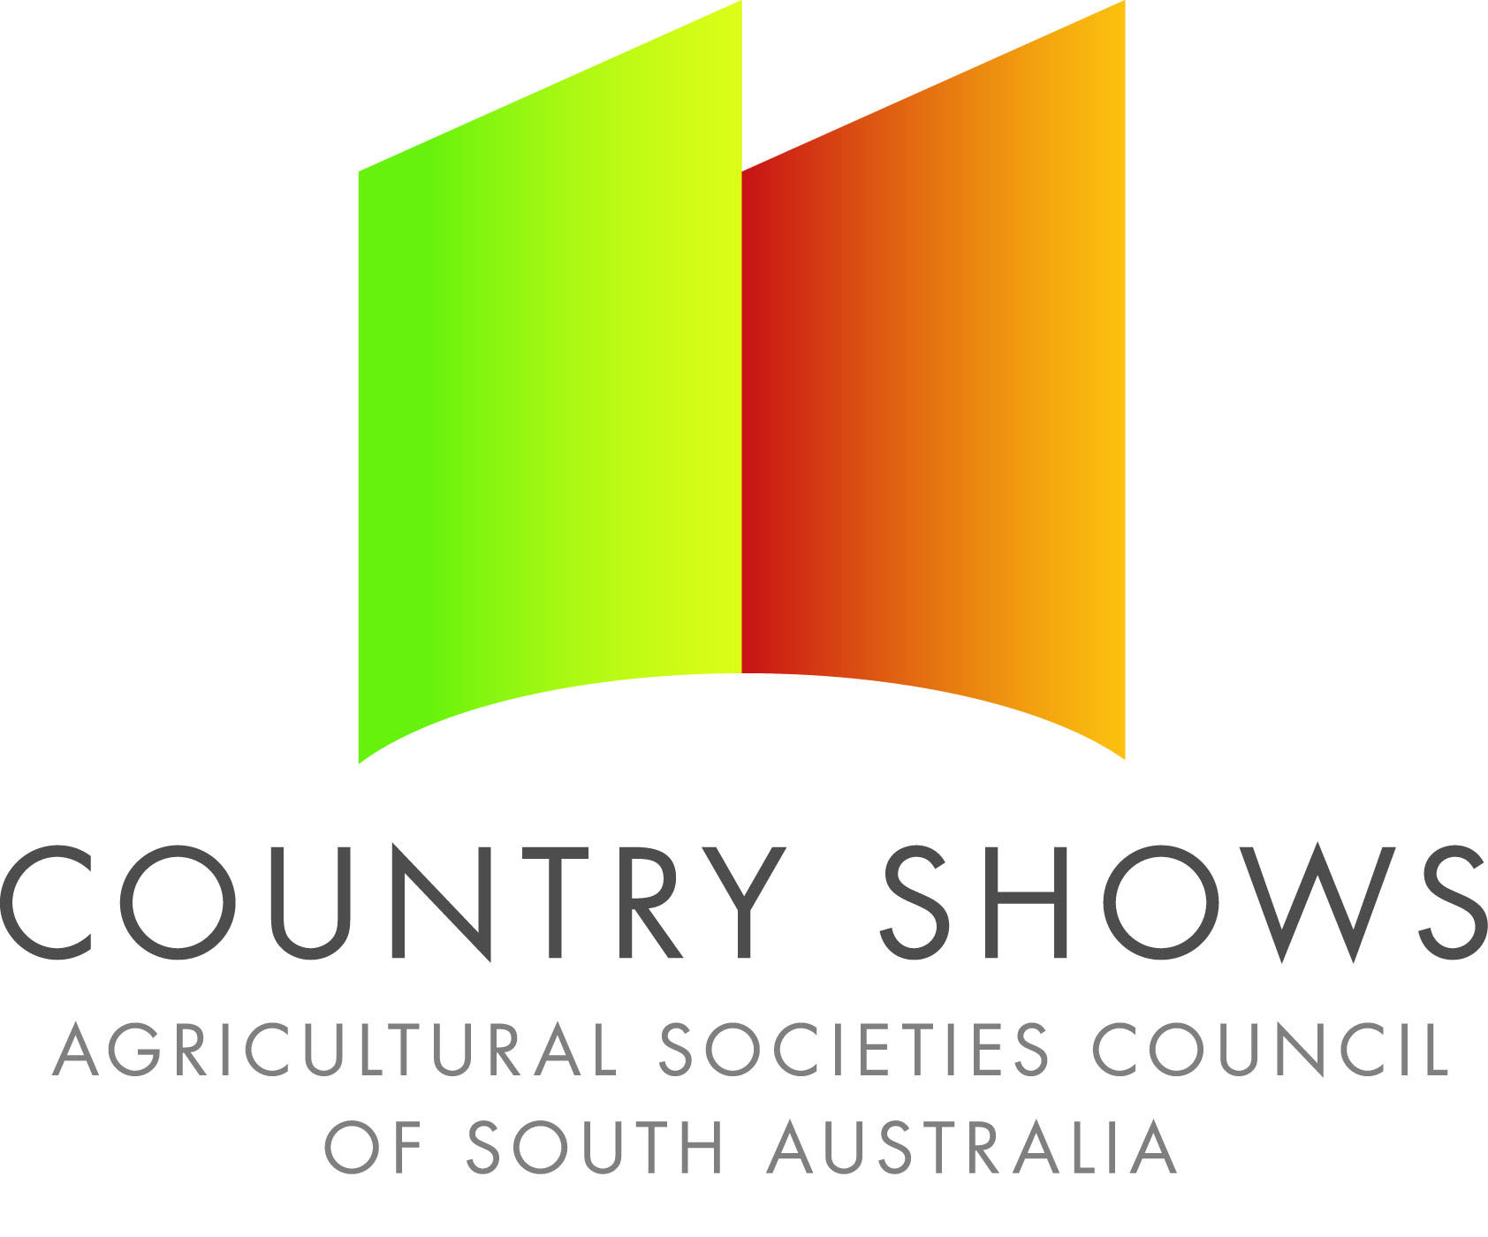
Laucke/CWA Scone Competition
Sponsored by Laucke Flour Mills

Competition Outline
- Best variation of the nominated scone recipe using Laucke Country Women's Scone Mix.
- Savoury and Sweet scones are alternated for competitions. Please check the SA Country Show’s website for this year’s flavour.
- Only one entry per person, no entry fee
- Entrants are only eligible to win one local final
- Winners from each local show to be eligible to enter and be judged at the nominated association show.
- The 10 association winners will compete in the State Final judged at the Royal Adelaide Show.

Judging Guidelines
- 5 scones to be presented for judging
- Scones should be approximately 5cms in diameter
- Well risen, straight sides, thin golden crust top and bottom, no flour base.
- Fine, moist texture, good crumb, good flavour and according to type.

State Final
- The 10 associations winners will be eligible to compete in the State Final held at the Royal Adelaide Show. Please check the SA Country Show’s website for the date.
- State finalists will be required to cook their best scone variation.
- The event will coincide with the judging of the Rich Fruit and Genoa Cake Competition state final.

Prize Allocation
LOCAL
1st - Laucke Goods Hamper (value approx $20)
2nd - Laucke Country Women's Scone Mix/Bread Storage Bag (value approx $6.00)
3rd - Laucke Country Women's Scone Mix / Bread Storage Bag (value approx $6.00)

ASSOCIATION
1st - $40.00
2nd - $20.00
3rd - $10.00
STATE
1st - $200.00
2nd - $75.00
3rd - $40.00

