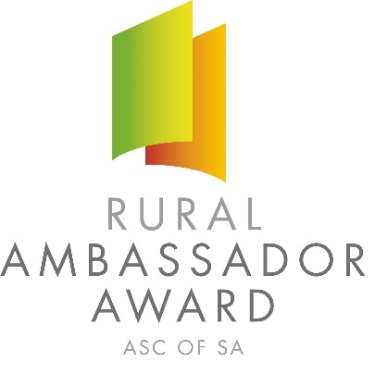

Dear SA Country Show Association and Show Secretaries,

Please find below the names and contact details for the 2019 South Australian Rural Ambassador Award Winner and Runner Ups.

As outlined in the award criteria if the state winner is from your Show and Show Association you are actively encouraged to extend an invitation for them to attend the following events over the next 12 months:

- Your local Show
- The Shows in your Show Association
- Your Show Association Annual General Meeting and Presentation Dinner/Night
- Judging of the following year’s Rural Ambassador Award association finalists

2019 South Australian Rural Ambassador Award Winner

Name: Karle Milde
Country Show: Eudunda
Show Association: Northern
Postal Address: PO Box 347 EUDUNDA SA 5374
Email: kmilde@y7mail.com Mobile: 0407 853 907

If one of the runner ups is from your Show and Show Association you are also encouraged to invite them to attend events in your region.

2019 South Australian Rural Ambassador Award Runner Ups

Name: Amy Doecke – 1st Runner Up
Country Show: Angaston
Show Association: Central
Postal Address: 10 Evans Street ANGASTON SA 5353
Email: amy_holmes07@hotmail.com Mobile: 0459 220 101

Name: Jacinta Jenkins – 2nd Runner Up
Country Show: Penola
Show Association: South East & Border
Postal Address: PO Box 347 PENOLA SA 5277
Email: jacinta.jenkins@hotmail.com Mobile: 0411 351 336

The availability of the winner and runner ups to attend events will depend on employment and other commitments. Encouraging all state finalists to remain involved in SA Country Shows is very important.

Yours sincerely,

Francis Andrews Peter Angus
President - SA Country Shows Rural Ambassador Award Coordinator

