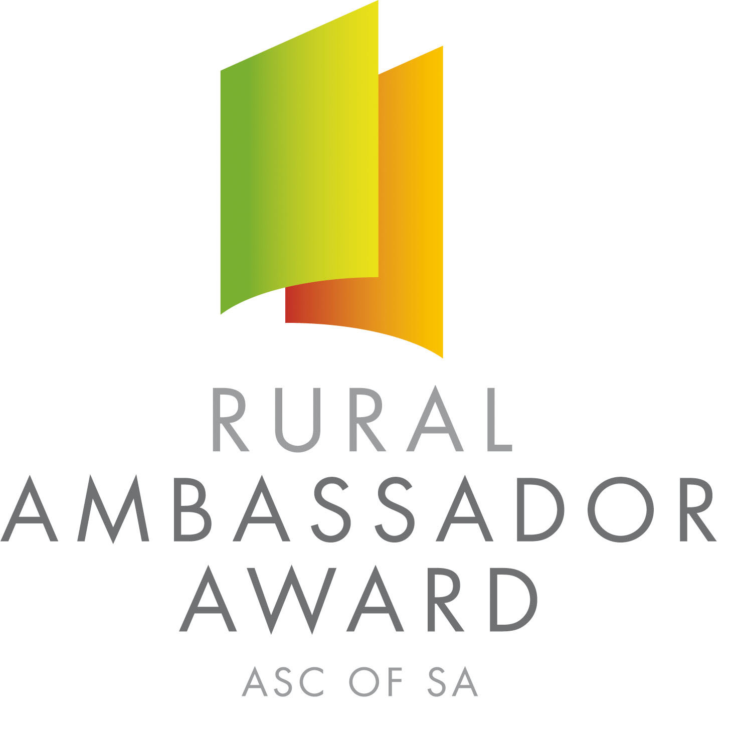

Dear SA Country Show Association and Show Secretaries,

Please find below the names and contact details for the 2018 South Australian Rural Ambassador Award Winner and Runner Ups.

As outlined in the award criteria if the state winner is from your Show and Show Association you are actively encouraged to extend an invitation for them to attend the following events over the next 12 months:

- Your local Show
- The Shows in your Show Association
- Your Show Association Annual General Meeting and Presentation Dinner/Night
- Judging of the following year’s Rural Ambassador Award association finalists

2018 South Australian Rural Ambassador Award Winner

Name: Christopher Hutchinson
Country Show: Kapunda
Show Association: Northern
Postal Address: 54 Jubilee Ave, ANGASTON SA 5353
Email: chris.hutchinson91@live.com.au Mobile: 0407 645 043

If one of the runner ups is from your Show and Show Association you are also encouraged to invite them to attend events in your region.

2018 South Australian Rural Ambassador Award Runner Ups

Name: Kevin Lintern – 1st Runner Up
Country Show: Mt Pleasant
Show Association: Central
Postal Address: PO Box 239, FREELING SA 5372
Email: kevin.d.lintern@gmail.com Mobile: 0428 057 058

Name: Matthew Hagger – 2nd Runner Up
Country Show: Jamestown
Show Association: Northern
Postal Address: PO Box 326, JAMESTOWN SA 5491
Email: haggermm@gmail.com Mobile: 0427 240 074

The availability of the winner and runner ups to attend events will depend on employment and other commitments. Encouraging all state finalists to remain involved in SA Country Shows is very important.

Yours sincerely,

Francis Andrews Peter Angus
President - SA Country Shows Rural Ambassador Award Coordinator

