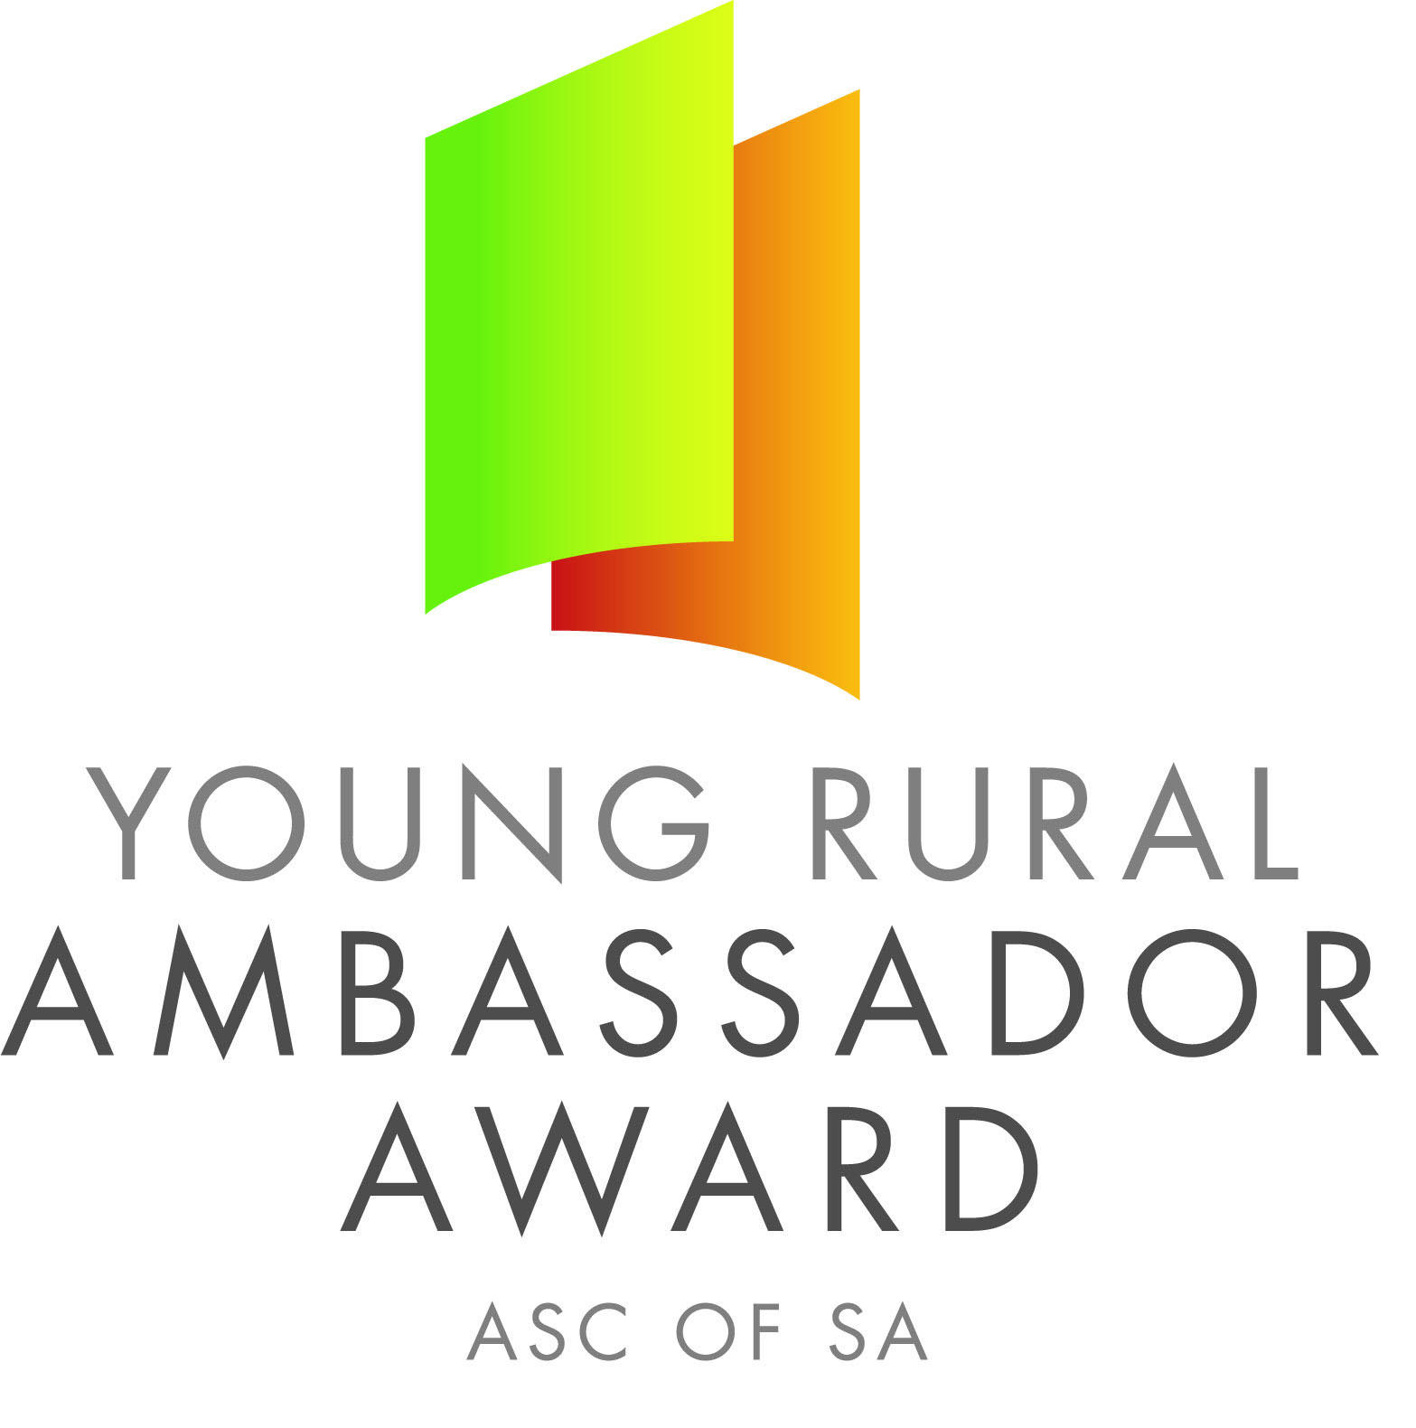

Dear SA Country Show Association and Show Secretaries,

Please find below the names and contact details for the 2018 South Australian Young Rural Ambassador Award Winner and Runner Up.

As outlined in the award criteria if the state winner is from your Show and Show Association you are actively encouraged to please extend an invitation for them to attend over the next 12 months the following events:

- Your local Show
- The Shows in your Show Association
- Your Show Association Annual General Meeting and Presentation Dinner/Night
- Judging of the following year’s Young Rural Ambassador Award finalists

2018 South Australian Young Rural Ambassador Award Winner

Name: Caitlin Heppner
Country Show: Mt Pleasant
Show Association: Central
Contact Details
Postal Address: PO Box 501 NURIOOTPA SA 5355
Email: caitlin.heppner@hotmail.com Mobile: 0439 365 646

If the runner up is from your Show and Show Association you are also encouraged to invite them to attend events in your region.

2018 South Australian Young Rural Ambassador Award Runner Up

Name: Franke Agenbag
Country Show: Gawler
Show Association: Northern
Contact Details
Postal Address: PO Box 1940 GAWLER POST OFFICE SA 5118
Email: franke1710@hotmail.com Mobile: 0413 415 622

The availability of the winner and runner up to attend events will depend on employment and other commitments. Encouraging finalists to remain involved in SA Country Shows is very important.

Yours sincerely,

Francis Andrews Peter Angus
President - SA Country Shows Young Rural Ambassador Award Coordinator

