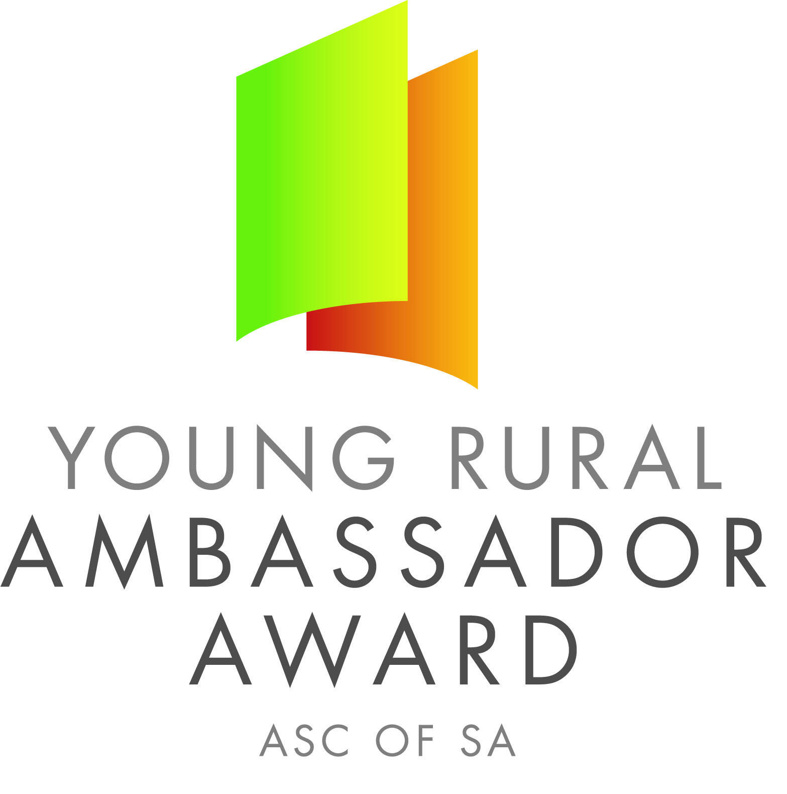

Dear SA Country Show Association and Show Secretaries,

Please find below the name and contact details for the 2017 South Australian Young Rural Ambassador Award Winner and Runner Up.

As outlined in the award criteria if the state winner is from your Show and Show Association you are actively encouraged to please extend an invitation for them to attend over the next 12 months the following events:

- Your local Show
- The Shows in your Show Association
- Your Show Association Annual General Meeting and Presentation Dinner/Night
- Judging of the following year’s Young Rural Ambassador Award finalists

2017 South Australian Young Rural Ambassador Award Winner

Name: Lachy Johnson
Country Show: Mundulla
Show Association: South East and Border
Contact Details
Postal Address: PO Box 569 Bordertown SA 5268
Email: lachlan.j11@hotmail.com Mobile: 0412 393 712

If the runner up is from your Show and Show Association you are also encouraged to invite them to attend events in your region.

2017 South Australian Young Rural Ambassador Award Runner Up

Name: Rebekah Starick
Country Show: Angaston
Show Association: Central
Contact Details
Postal Address: 71 Bormann Road Punthari SA 5238
Email: becstarick.1997@gmail.com Mobile: 0419 380 151

The availability of the winner and runner up to attend events will depend on employment and other commitments. Encouraging finalists to remain involved in SA Country Shows is very important.

Yours sincerely,

Janet King Peter Angus
President - SA Country Shows Young Rural Ambassador Award Coordinator

