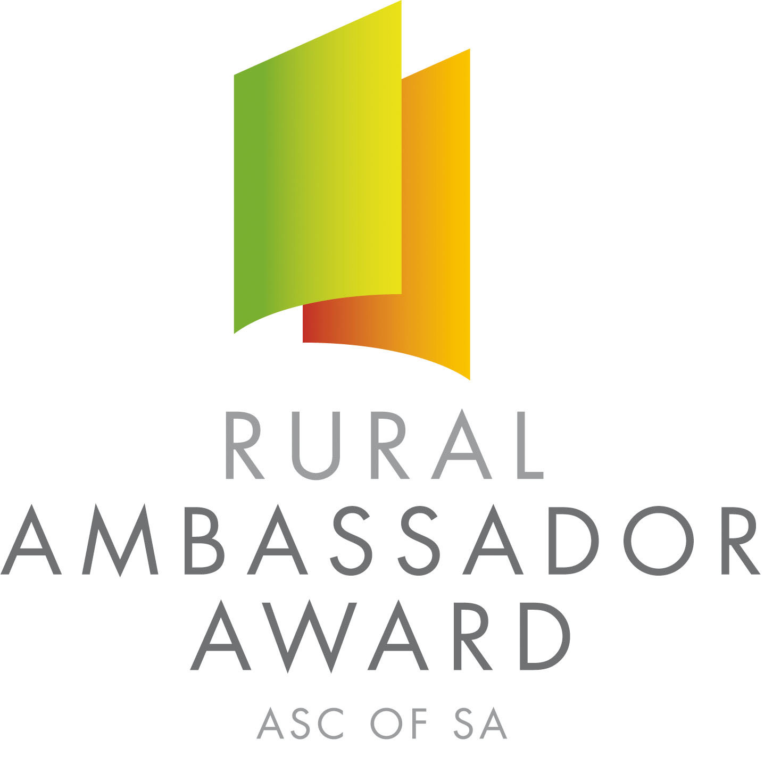

Dear SA Country Show Association and Show Secretaries,

Please find below the names and contact details for the 2017 South Australian Rural Ambassador Award Winner and Runner Ups.

As outlined in the award criteria if the state winner is from your Show and Show Association you are actively encouraged to please extend an invitation for them to attend over the next 12 months the following events:

- Your local Show
- The Shows in your Show Association
- Your Show Association Annual General Meeting and Presentation Dinner/Night
- Judging of the following year’s Rural Ambassador Award association finalists

2017 South Australian Rural Ambassador Award Winner

Name: Sarah Hazel
Country Show: Kapunda
Show Association: Northern
Contact Details
Postal Address: 6 First Street Orroroo SA 5431
Email: hazeljsarah@gmail.com Mobile: 0430 353 661

If one of the runner ups is from your Show and Show Association you are also encouraged to invite them to attend events in your region.

2017 South Australian Rural Ambassador Award Runner Ups

Name: Stefan Anesbury
Country Show: Gawler
Show Association: Northern
Contact Details
Postal Address: 10 Dawes Drive Gawler East SA 5118
Email: stefo96@hotmail.com Mobile: 0434 390 466

Name: Kate Fairlie
Country Show: Penola
Show Association: South East & Border
Contact Details
Postal Address: PO Box 1021 Mt Gambier SA 5290
Email: fairlie.kate@gmail.com Mobile: 0448 248 598

The availability of the winner and runner ups to attend events will depend on employment and other commitments. Encouraging all state finalists to remain involved in SA Country Shows is very important.

Yours sincerely,

Janet King Peter Angus
President - SA Country Shows Rural Ambassador Award Coordinator

