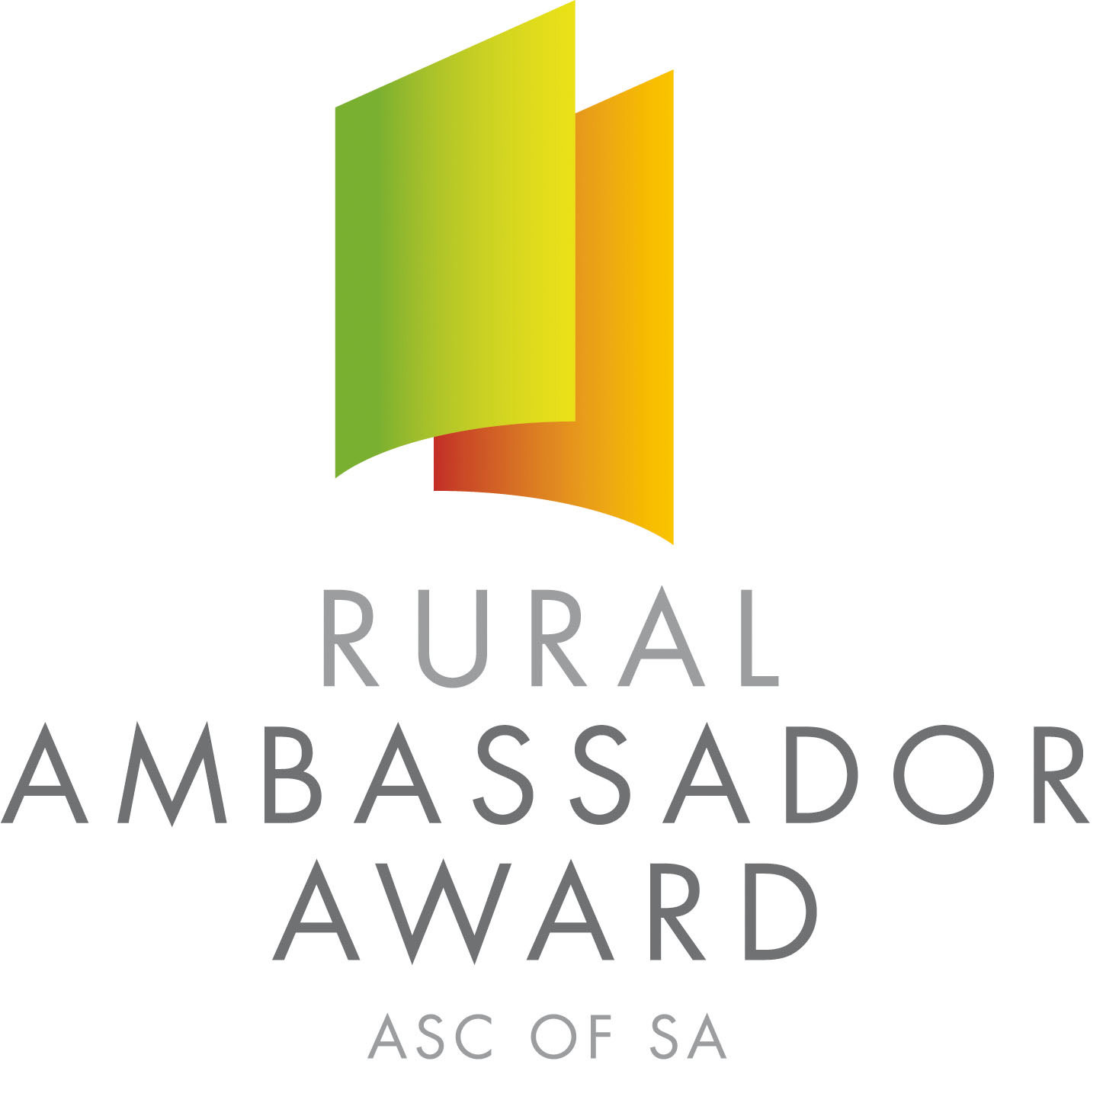

Dear SA Country Show Association and Show Secretaries,

Please find below the name and contact details for the 2015 South Australian Rural Ambassador Award Winner and Runner Ups.

As outlined in the award criteria if the state winner is from your Show and Show Association you are actively encouraged to please extend an invitation for them to attend over the next 12 months the following events:

- Your local Show
- The Shows in your Show Association
- Your Show Association Annual General Meeting and Presentation Dinner/Night
- Judging of the following year’s Rural Ambassador finalists

2015 South Australian Rural Ambassador Award Winner

Name: Jeremy Schutz
Country Show: Pinnaroo
Show Association: Murray Lands
Contact Details
Postal Address: 14 Adelaide Road, Pinnaroo SA 5304
Email: butza1991@gmail.com Mobile: 0408 105 892

If one of the runner ups is from your Show and Show Association you are also encouraged to invite them to attend events in your region.

2015 South Australian Rural Ambassador Award Runner Ups

Name: Cassie Ryan
Country Show: Keith
Show Association: South East and Border
Contact Details
Postal Address: 9 Memorial Avenue, Keith SA 5267
Email: cryan@coxrural.com.au Mobile: 0401 343 750

Name: Damien Liebelt
Country Show: Uraidla & Summertown
Show Association: Central
Contact Details
Postal Address: PO Box 1036, Uraidla SA 5142
Email: moethatturkey@yahoo.com.au Mobile: 0421 382 359

The availability of the winner and runner ups to attend events will depend on employment and other commitments. Encouraging all state finalists to remain involved in SA Country Shows is very important.

Yours sincerely,

Janet King Peter Angus
President - SA Country Shows Rural Ambassador Award Coordinator

